**ELEC97094/ELEC97095 Wireless Communications**

Coursework 2: Link-level Performance

Evaluation of MIMO

Zhaolin Wang

1. **QPSK Modulation**

In this coursework, the QPSK modulation with Gray coding is used. The constellation is shown below.

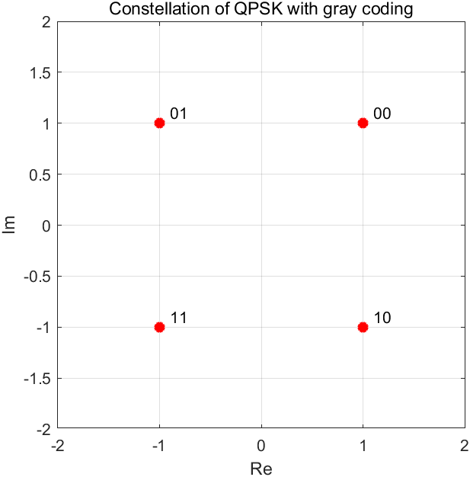

Fig 1. Constellation of QPSK (Gray coding)

For adjacent symbols in this constellation, there is only one different bit, therefore the relationship between the symbol error rate $P_{s}$ and the bit error rate (BER) $P_{e}$ at high SNR is

|  |  |  |
| --- | --- | --- |
|  | $$P_{e}=\frac{P_{s}}{2}$$ | (1) |

1. **Task 1: Performance Analysis**

Considering a deterministic point-to-point MIMO channel with CSIT, the multiple (including dominant) eigenmode transmission can be applied. The transmission in this case can be denoted by

|  |  |  |
| --- | --- | --- |
|  | $$y=HV_{H}c+n,$$ | (2) |

where $H∈{\text{C}}^{n_{r}×n_{t}}$ is the deterministic channel matrix, $V_{H}∈{\text{C}}^{n_{t}×n_{t}}$ is the precoder obtained from the right singular matrix of $H$, $c∈{\text{C}}^{n_{t}×1}$ is the transmitted symbols, and $n$ is the complex Gaussian noise vector with the distribution $\text{CN}\left(0,N_{0}\right)$. At the receiver, the detector $U_{H}^{H}∈{\text{C}}^{n_{r}×n_{r}}$ is obtained from the left singular matrix of $H$, and the received symbols are given by

|  |  |  |
| --- | --- | --- |
|  | $$z=U_{H}^{H}y$$ | (3a) |
|  | $$=U_{H}^{H}HV_{H}c+U_{H}^{H}n$$ | (3b) |
|  | $$=Σ_{H}c+\tilde{n}$$ | (3c) |

where $Σ_{H}=diag\{σ_{1},…,σ_{n}\}∈{\text{C}}^{n_{r}×n_{t}}$ is the singular value matrix and $n=\min\left(n_{r},n_{t}\right)$. As the $U_{H}^{H}$ is unitary, $\tilde{n}$ has the same distribution as $n$.

The mutual information with the deterministic MIMO channel is given by

|  |  |  |
| --- | --- | --- |
|  | $$\text{I}\left(\tilde{H},Q\right)=\log_{2}{\det\left[I_{n_{r}}+\frac{\tilde{H}Q{\tilde{H}}^{H}}{N_{0}}\right]}$$ | (4) |

where $Q$ is the covariance matrix and the $\tilde{H}$ is the equivalent MIMO channel matrix. The matrix $Q$ is given by

|  |  |  |
| --- | --- | --- |
|  | $$Q=E\left[V_{H}c{\left(V_{H}c\right)}^{H}\right]=E\left[V_{H}cc^{H}V_{H}^{H}\right]$$ | (5a) |
|  | $$=V_{H}diag\{s_{1},…,s_{n_{t}}\}V_{H}^{H}$$ | (5b) |

where $s_{i},i=1,…,n_{t}$ are the power allocation coefficients, which satisfies the overall power constraint $\sum_{i=1}^{n_{t}}{s_{i}}≤P$. According to (3b), the equivalent MIMO channel matrix $\tilde{H}$ is given by

|  |  |  |
| --- | --- | --- |
|  | $$\tilde{H}=U_{H}^{H}H$$ | (6) |

Based on (5b) and (6), the mutual information in (4) can be rewritten as

|  |  |  |
| --- | --- | --- |
|  | $$\text{I}\text{(}H,s_{i})=\log_{2}{\det\left[I_{n_{r}}+\frac{Σ_{H}diag\{s_{1},…,s_{n_{t}}\}{Σ_{H}}^{H}}{N_{0}}\right]}$$ | (7a) |
|  | $$=\sum_{k=1}^{n}{\log_{2}\left(1+\frac{s_{k}σ_{k}^{2}}{N_{0}}\right)}$$ | (7b) |

In this case, the following optimization problem (8) need to be solved to find the optimal power allocation coefficients $s_{i}$ that achieve the channel capacity.

|  |  |  |
| --- | --- | --- |
|  | $$\max_{s_{i}}\text{I}\text{(}H,s_{i})$$ | (8a) |
|  | $$s.t.\sum_{i=1}^{n_{t}}{s_{i}}≤P$$ | (8b) |

The solution of the optimization problem (8) is given by the water-filling solution of the Lagrangian,

|  |  |  |
| --- | --- | --- |
|  | $$s_{k}^{*}={\left(μ-\frac{N_{0}}{σ_{k}^{2}}\right)}^{+},k=1,…,n$$ | (9) |

where $μ$ is chosen to satisfy (8b) and is given by

|  |  |  |
| --- | --- | --- |
|  | $$u=\frac{1}{n}\left(P+\sum_{k=1}^{n}{\frac{N_{0}}{σ_{k}^{2}}}\right)$$ | (10) |

Considering the following two MIMO channel matrix

|  |  |  |
| --- | --- | --- |
|  | $$H_{1}=\left[\begin{matrix}1 & 1 \\ 1 & 1\end{matrix}\right],$$ | (11) |
|  | $$H_{2}=\left[\begin{matrix}\sqrt{2} & 0 \\ 0 & \sqrt{2}\end{matrix}\right],$$ | (12) |

their SVDs are given by

|  |  |  |
| --- | --- | --- |
|  | $$H_{1}=U_{1}Σ_{1}V_{1}^{H}=U_{1}\left[\begin{matrix}2 & 0 \\ 0 & 0\end{matrix}\right]V_{1}^{H},$$ | (13) |
|  | $$H_{2}=U_{2}Σ_{2}V_{2}^{H}=U_{2}\left[\begin{matrix}\sqrt{2} & 0 \\ 0 & \sqrt{2}\end{matrix}\right]V_{2}^{H}.$$ | (14) |

It is noticeable that the rank of the channel matrix $H_{1}$ is 1, which leads to only 1 non-zero singular value, therefore this channel can only support 1 symbol stream. According to (7b), the mutual information in this case is given by

|  |  |  |
| --- | --- | --- |
|  | $${\text{I}}_{H_{1}}\text{(}s_{1,H_{1}})=\log_{2}\left(1+\frac{{4s}_{1,H_{1}}}{N_{0}}\right).$$ | (15) |

In this case, it is obvious that all the power $P$ needs to be allocated to the $s_{1,H_{1}}$ (i.e., $s_{1,H_{1}}=P$) in order to achieve the channel capacity. Therefore, the channel capacity with $H_{1}$ is

|  |  |  |
| --- | --- | --- |
|  | $${\text{C}}_{H_{1}}=\log_{2}\left(1+\frac{4P}{N_{0}}\right).$$ | (16) |

For the channel matrix $H_{2}$, its rank is 2 and there are 2 non-zero singular values. According to (7b), the mutual information in this case is given by

|  |  |  |
| --- | --- | --- |
|  | $${\text{I}}_{H_{2}}\text{(}s_{1,H_{2}},s_{2,H_{2}})=\sum_{k=1}^{2}{\log_{2}\left(1+\frac{{2s}_{k,H_{2}}}{N_{0}}\right)}.$$ | (17) |

Based on the water-filling solution (9) and (10), the optimal power allocation for $H_{2}$ is $s_{1,H_{2}}=s_{2,H_{2}}=P/2$. In this case, the capacity for $H_{2}$ is

|  |  |  |
| --- | --- | --- |
|  | $${\text{C}}_{H_{2}}=2 \log_{2}\left(1+\frac{P}{N_{0}}\right).$$ | (18) |

Observing (16) and (18), the capacity in the case of $H_{1}$ and $H_{2}$ are determined by the SNR (i.e., $P/N_{0}$). Figure 2 shows the comparison of channel capacity against SNR in the two cases.

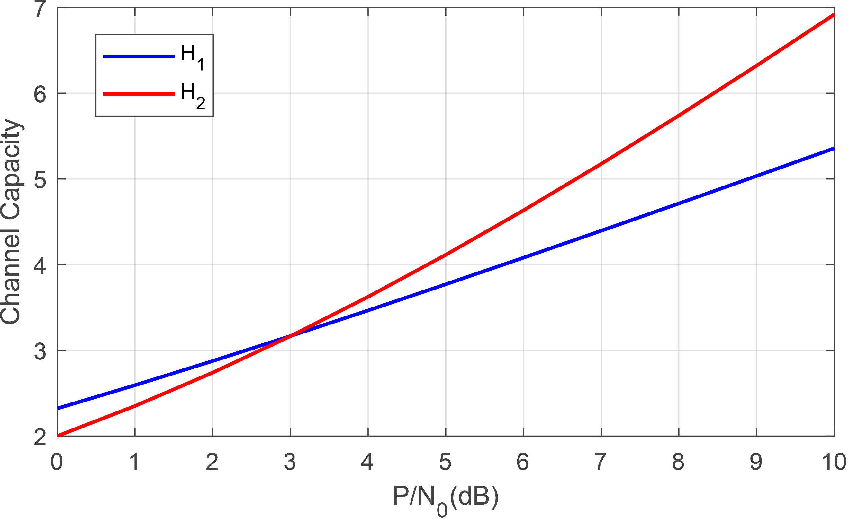

Figure 2. Comparison of channel capacity

For the small value of SNR (i.e., SNR < 3dB), the channel $H_{1}$ leads to the largest capacity, while for a large value of SNR (i.e., SNR > 3dB), the channel $H_{2}$ leads to the largest capacity. The reason is that the MIMO channel $H_{2}$ offers larger multiplexing gain, which is defined as

|  |  |  |
| --- | --- | --- |
|  | $$g_{s}=\lim_{ρ→∞}{\frac{R\left(ρ\right)}{\log_{2}\left(ρ\right)}}.$$ | (19) |

where $ρ=P/N_{0}$ is the SNR. According to (16), (18), and (19), the multiplexing gain for MIMO channels $H_{1}$ and $H_{2}$ are

|  |  |  |
| --- | --- | --- |
|  | $$g_{s,H_{1}}=1,$$ | (20) |
|  | $$g_{s,H_{2}}=2.$$ | (21) |

Therefore, the transmission rate increases faster in channel $H_{2}$, which leads to the largest capacity at high SNR.

1. **Task 2: Ergodic Capacity for CSIT and CDIT**

With perfect channel knowledge at transmitter (CSIT), the channel can be regarded as the deterministic channels, where the optimal power allocation is given by water-filling solutions (9) and (10) to achieve the channel capacity.

While for the partial channel knowledge at the transmitter (CDIT), a power allocation scheme is needed to achieve the ergodic capacity over many channel realizations because of the short coherence time. The ergodic capacity is defined as

|  |  |  |
| --- | --- | --- |
|  | $$\overline{\text{C}}=\max_{Q≥0:Tr\{Q\}=P}{E\left\{\log_{2}{\det\left[I_{n_{r}}+\frac{HQH^{H}}{N_{0}}\right]}\right\}}.$$ | (22) |

The optimal power allocation for the ergodic capacity (22) in i.i.d. Rayleigh fading channel is given by the equal power allocation scheme $s_{1}=…=s_{n_{t}}$, i.e., $Q=I_{n_{t}}P/n_{t}$. In this case, the ergodic capacity for CDIT is given by

|  |  |  |
| --- | --- | --- |
|  | $$\overline{\text{C}}=E\left\{\log_{2}{\det\left[I_{n_{r}}+\frac{P}{N_{0}n_{t}}HH^{H}\right]}\right\}.$$ | (23a) |
|  | $$=E\left\{\sum_{k=1}^{n}{\log_{2}\left[1+\frac{P}{N_{0}n_{t}}σ_{k}^{2}\right]}\right\}$$ | (23b) |

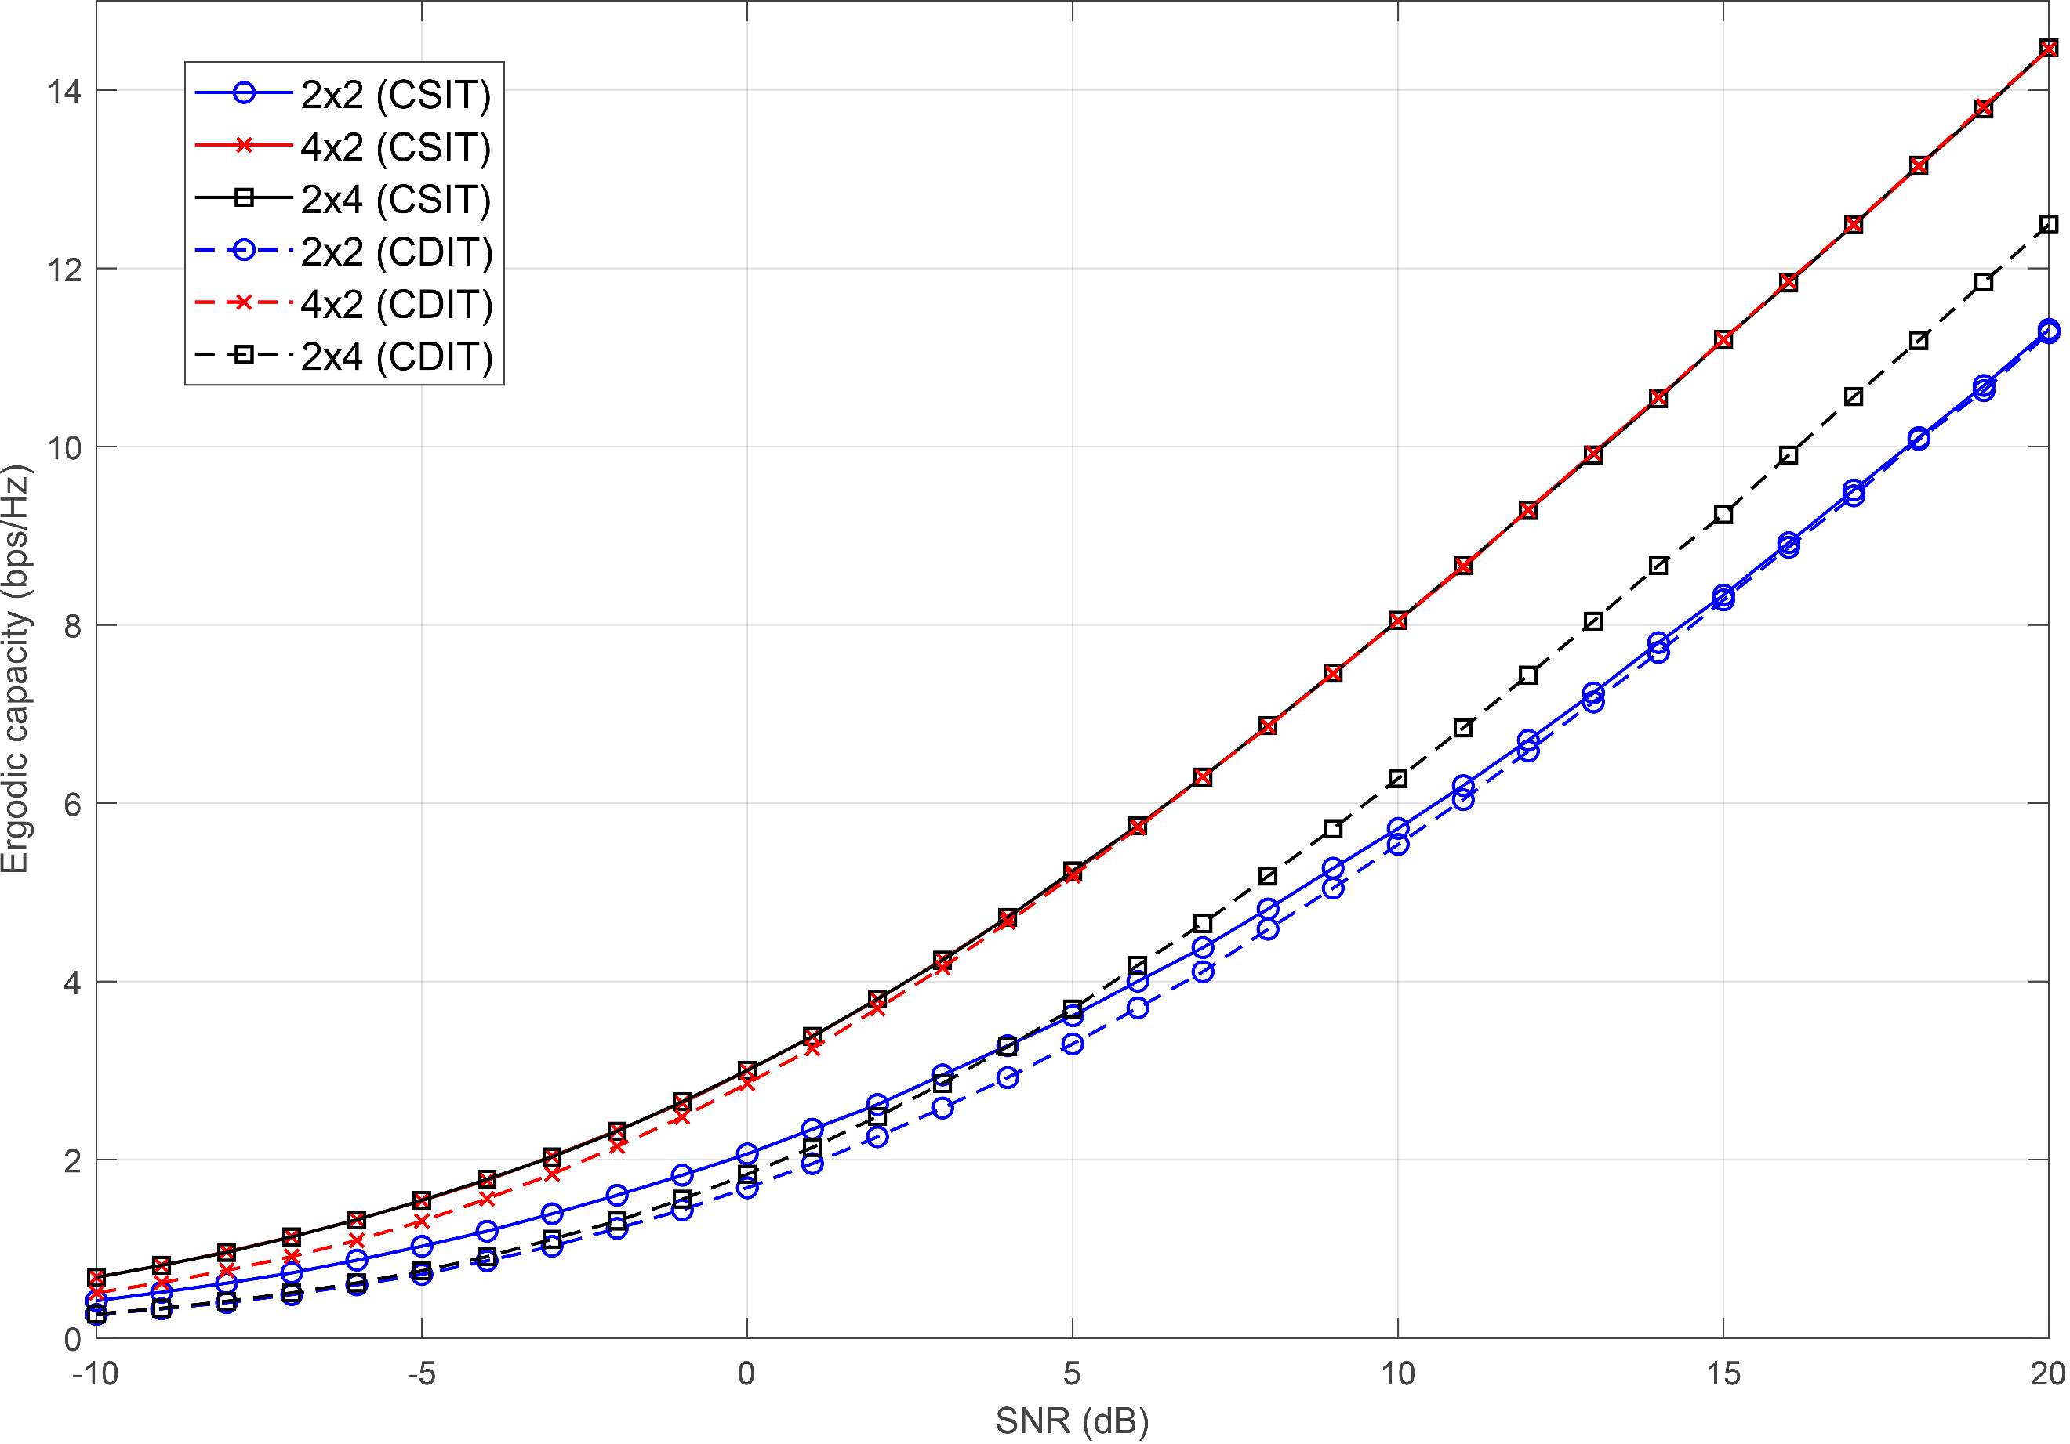

Figure 3 Ergodic capacity of $n_{r}×n_{t}=2×2, 4×2 and 2×4$ i.i.d. Rayleigh fading channels with full (CSIT) and partial (CDIT) knowledge at the transmitter.

Figure 3 shows the simulation results of ergodic capacity with CSIT and CDIT in different MIMO channels.

In the case of CSIT, the water-filling solution leads to the dominant eigenmode transmission in the condition of low SNR, where only the largest singular value $σ_{max}$ is exploited and allocated with all the power. The capacity with CSIT in low SNR is given by

|  |  |  |
| --- | --- | --- |
|  | $${\overline{\text{C}}}_{CSIT}\underset{→}{P/N_{0}→0}\log_{2}\left(1+\frac{P}{N_{0}}σ_{max}^{2}\right).$$ | (24) |

While in the condition of high SNR, the water-filling solution will lead to the equal power allocation among all the modes with non-zero singular values, where the capacity of given by

|  |  |  |
| --- | --- | --- |
|  | $${\overline{\text{C}}}_{CSIT}\underset{→}{P/N_{0}→∞}\sum_{k=1}^{n}{\log_{2}\left(1+\frac{P}{N_{0}}σ_{k}^{2}\right)}$$ | (25a) |
|  | $$≅n\log_{2}{\frac{P}{nN_{0}}}+\sum_{k=1}^{n}{\log_{2}\left(σ_{k}^{2}\right)}.$$ | (25b) |

The multiplexing gain in the case of CSIT is determined by the expression (25), where the multiplexing gain is $g_{s}=n$.

In the case of CDIT, the equal power allocation scheme is applied for any SNR. According to (23b), the capacity for CDIT at high SNR is given by

|  |  |  |
| --- | --- | --- |
|  | $${\overline{\text{C}}}_{CDIT}\underset{→}{P/N_{0}→∞}E\left\{\sum_{k=1}^{n}{\log_{2}\left[\frac{P}{N_{0}n_{t}}σ_{k}^{2}\right]}\right\}$$ | (26a) |
|  | $$=n\log_{2}{\frac{P}{n_{t}N_{0}}}+E\left\{\sum_{k=1}^{n}{\log_{2}\left(σ_{k}^{2}\right)}\right\}.$$ | (26b) |

Therefore, the multiplexing gain in the case of CDIT is also $g_{s}=n$.

In Figure 3, the channel matrices in all the conditions have $n=\min\left(n_{r},n_{t}\right)=2$, which means the multiplexing gain $g_{s}=2$.

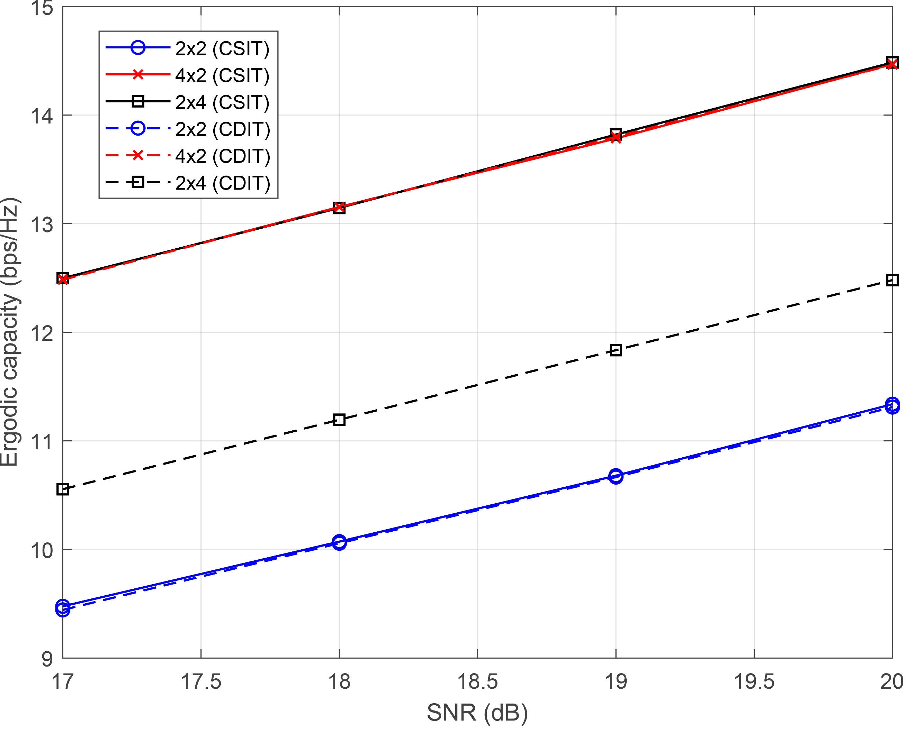

Figure 4 High SNR part (17dB~20dB) of Figure 2

Observing the high SNR part in Figure 3 (shown by Figure 4), the SNR is increased by 3dB from 17dB to 20dB, in which interval the ergodic capacity in all cases is increased by around 2 bps/Hz. Therefore, the simulation result indicate that the multiplexing gain is $g_{s}=2$, which is inline with the theory.

In the conditions of $4×2$ and $2×4$ channels with CSIT, their curves in Figure 2 are overlapped, which means they have the same capacity. The reason is that the $4×2$ channel matrix can be treated as the transpose of the $2×4$ channel matrix, and vice versa. Therefore, the two channel matrices have the same singular values, resulting in the same channel capacity.

Comparing the CSIT and CDIT of $2×2$ channels in the simulation results, the ergodic capacity of CDIT is smaller than that of CSIT in relative low SNR while gradually approaching the capacity of CSIT with the increase of SNR. The reason is that the equal power allocation leads to a smaller capacity compared with the dominant eigenmode transmission at low SNR. However, with the increase of the SNR, the optimal power allocation gradually approaches the equal power allocation, which is the same as the power allocation scheme used in CDIT.

The simulation results of the CSIT and CDIT of $4×2$ channels show a similar phenomenon as $2×2$ channels because of the same reason. However, the phenomenon is different for $2×4$ channels, where there is a huge gap between the two curves of CSIT and CDIT. Actually, another significant reason for CSIT and CDIT in $4×2$ or $2×2$ channels having similar capacity at high SNR is that $n=\min{\{}n_{r},n_{t}\}=n_{t}=2$ in these two cases, causing the similar capacity result (referring to (25b) and (26b)). While for the $2×4$ channel, $n=2$ and $n_{t}=4$, therefore the ergodic capacity of CDIT (26b) is smaller than that of CSIT (25b).

1. **Task 3: Different Receivers for Spatial Multiplexing**

In spatial multiplexing, the independent data streams are transmitted on each transmit antenna. The codeword transmitted in one symbol duration is

|  |  |  |
| --- | --- | --- |
|  | $$C=\frac{1}{\sqrt{n_{t}}}{\left[c_{1},…,c_{n_{t}}\right]}^{T}.$$ | (27) |

where $c_{q},q=1,…,n_{t}$ are symbols chosen from the constellation (QPSK is assumed in this coursework).

In the maximum likelihood (ML) receiver, the codebook containing all the possible codewords is traversed to find the best one based on the minimum distance criterion. The error probability of ML receiver is given by

|  |  |  |
| --- | --- | --- |
|  |  | (28) |

Based on (28), the diversity gain of ML receiver is $g_{d}^{o}\left(ρ\right)=n_{r}$.

In the zero-forcing (ZF) receiver, the zero forcing detector is exploited to cancel the interference in each stream. The zero-forcing detector is defined as

|  |  |  |
| --- | --- | --- |
|  | $$G_{ZF}=\sqrt{\frac{n_{t}}{E_{s}}}H^{†}.$$ | (29) |

where $H^{†}={\left(H^{H}H\right)}^{-1}H^{H}$. The error probability of ZF receiver is given by

|  |  |  |
| --- | --- | --- |
|  |  | (30) |

Therefore, the diversity gain of ZF receiver is $g_{d}^{o}\left(ρ\right)=\left(n_{r}-n_{t}+1\right)$.

In the ZF successive interference canceler (ZF SIC) receiver, the symbol at top stream is detected using zero forcing, encoded, and removed from the received signal. In this case, there is no interference imposed by this symbol in other streams. This procedure is repeated until all the symbols are detected. For the symbol detected at the iteration $i$, the diversity gain is $g_{d}^{o}\left(ρ\right)=\left(n_{r}-n_{t}+i\right)$.

In the $2×2$ i.i.d Rayleigh fading channel, according to above analysis, the diversity gain of ML detector is $g_{d,ML}^{o}=2$. For ZF receiver, the diversity gain is $g_{d,ZF}^{o}=1$. For ZF SIC receiver, diversity gain of the first stream is $g_{d,ZFSIC,1}^{o}=1$, and diversity of the second stream is $g_{d,ZFSIC,2}^{o}=2$.

Figure 5 shows the simulation results of bit error rates of the ML, ZF, and ZF SIC receivers in $2×2$ i.i.d Rayleigh fading channel with QPSK constellation.

For the curve of ML, in the SNR interval from 10dB to 20dB, the bit error rate is decreased by around ${10}^{-2}$, which indicates the theoretical diversity gain of ML detector (i.e., $g_{d,ML}^{o}=2$).

For the curve of ZF, in the same SNR interval, the bit error rate is decreased by around ${10}^{-1}$, which is inline with the theoretical diversity gain $g_{d,ZF}^{o}=1$.

For the curve of ZF SIC, it is lower than the curve of ZF. The reason is that the diversity gain of the second stream in ZF SIC receiver is larger than that in the ZF receiver. However, the overall diversity gain of the ZF SIC is dominant by the lowest diversity in the single later. In this case, the overall diversity gain of ZF SIC is $g_{d,ZF SIC}^{o}≈1$, which is the same as the ZF receiver. It can be indicated by that the curve of ZF SIC in Figure 5 is almost parallel with that of ZF.

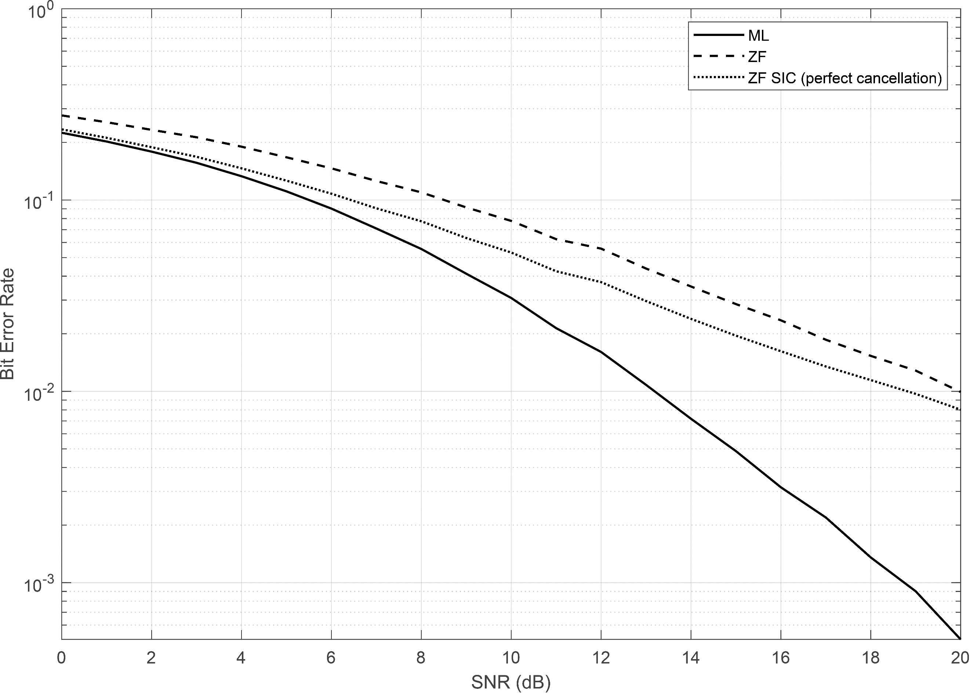

Figure 5 Bit error rate of ML, ZF, and ZF SIC receivers in $2×2$ i.i.d Rayleigh fading channel with QPSK constellation.